

Functionality Specification

Batch Query Life Cycle

Date: 19.12.2023
Prepared by: PHORN Vathanak

Document Control:
Document Name: | Functional Requirement Specification
System: | CRM Inhouse
Function | Batch Query Life Cycle
File Name: | Functionality Requirement Specification - CRM Inhouse - Batch Query Life Cycle

Document Reviewers:
Name | Role | Position | Company | Approver | Reviewer
CHAO Chivoeung | Credit Control Manager | Smart Axiata
PROUM Sodanearth | Credit Control Officer | Smart Axiata | x

1. Purpose of Document
The Functional Requirement Specification (FRS) is a document that provides detailed information on how the system solution will function and the requested behavior. This document is created based on the high-level requirements identified in the Business Requirements Document and provides traceability on the functional specifications back to the business requirements. Included in this document will be the detailed functional requirements including business cases, system inputs, outputs, logical system, and data source.
2 Batch Query Life Cycle
2.1 Process Flow

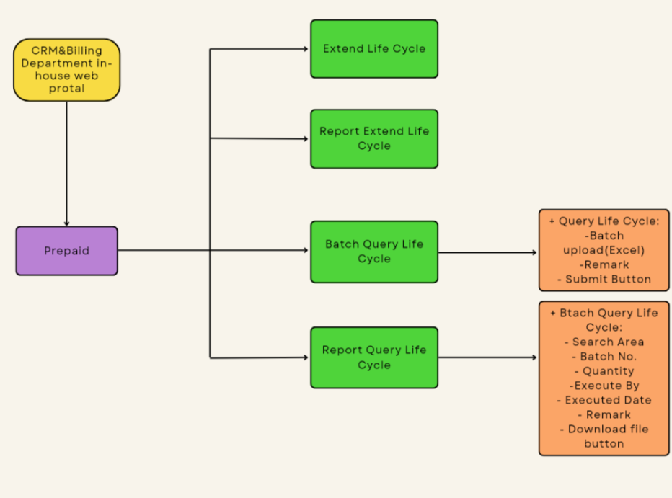

2.1 Process Details
- Purpose of function: Credit control team easy to check the subscriber’s life cycle many numbers with this function. Because currently Credit Control team check life cycle subscriber one by one in system NGBSS.

- Data Input: User must upload excel files to process this function. File sample as below:

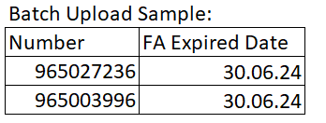

- Data Show: Data display to user such as Batch No, Phone Number, Subscriber Name,
Subscriber Status, Days Left, Executed By, Executed Date, FA Expired Date, Extended Date
, Expired Date, Suspension Date, Deactivate Date, Valid.
Sample as below:

Note 1. Data Value:
- Yes: FA Expired Date = Expired Date
- No: FA Expired Date != Expired Date

2. Maximum number for uploading is 500 numbers in one batch.
- Document Sign Off

Review and approved by: Review by: Credit Control Officer Prepare by:
Credit Control Manager Junior CRM Administrator

------------------------- ------------------------- -------------------------
CHAO Chivoeung PROUM Sodanearth PHORN Vathanak
Date: Date: Date: 20.12.2023

